
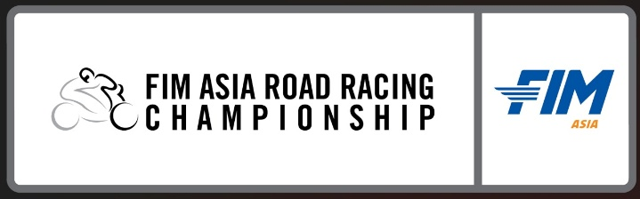

ENTRY FORM – WILD CARD
COURSE / EVENT: DATE: IMN No
FIM ASIA ROAD RACING CHAMPIONSHIP 2026 11th – 14th June 2026 140/04
ROUND 3, MOBILITY RESORT MOTEGI, JAPAN

Rider’s Full Name (as stated in Passport): Local License No:

COUNTRY: BLOOD TYPE: _______________________

FMN’s: NATIONALITY:
(Federation)
TEL: FAX:

ENTRANT NAME / TEAM NAME: TEAM ENTRANT LICENSE NO:
___

Race Machine: Make: Model: Year:
Race Category:
Entry Fee USD4,850.00 ASB1000 Competition No.
USD3,800.00 SS600 Competition No.

USD3,000.00 AP250 Competition No.

(All entry form and indemnity form must be completely filled and signed. Please enclosed together your FMN competition license and FMN entrant license)

INDEMNITY DECLARATION
- I/We have read the Supplementary Regulations issued for this meeting and agree to be bound by them and by the Asian Competition Rules of the FIM Asia. In consideration of the acceptance of this entry or of our being permitted to take part in the meeting. I/We agree to save harmless and keep indemnified the organizer & promoters Two Wheels Motor Racing, FIM Asia (FIM), Mobility Resort Motegi, Motorcycle Federation of Japan (MFJ) , Sponsors, Donors and their respective officials, servants, representatives and agents, from against all actions, claim, costs, expenses for death/or personal injury to myself/ourselves or loss or damage to the property of myself/ourselves and riders/drivers, passenger or mechanics and All members of my/our team (as the case may be) however caused arising out of or in connection with this entry and my/our taking part in this race meeting and notwithstanding that the same may have been contributed or occasioned by the negligence of the said bodies, their officials, servants, representatives or agents.

- I/We declare to the best of my/our belief that the driver(s)/rider(s) possess the standard of competence necessary for an event of this type to which this entry relates and the vehicle entered is suitable and road worthy for the event having regard to the course and the speeds which will be reached.

- I also acknowledge and agree that Two Wheels Motor Racing Sdn Bhd (TWMR )shall have the full, unfettered right to: (a) refer to me, and to use my name, image, likeness, voice and biographical information in respect of all advertising, promotional and publicity material in connection with or relating to the Event; and (b) record and film and obtain copyright from my participation in the Event and/or in any related events (whether by audio or audio-visual means or howsoever) and take photographs of me during or in relation to the Event and/or in any related events, and (c) in each case use and exploit (in perpetuity and worldwide) such pictures, audio and/or audio-visual footage in respect of me and my participation in the Event, in any now known or in the future developed support or media any and all purposes , including commercial, advertising, promotional and publicity purposes

- I/We declare that I/We and all other persons in any way connected with this entry recognize and accept that the jurisdiction in all matters arising out of this race meeting is vested in the organizers, promoters, circuit and Motorcycle Federation of Japan and that is under the International Sporting Code of the FIM Asia.

Name of Participant:  Date of Birth: | Participant Signature: | Date:  11th June 2026
Name of Team Entrant: | Authorized Signature: | Date:  11th June 2026

The above declaration must be signed by the parent (s) / legal guardian if the competitor is under the age of 18 as at the date of this entry.

Name of parent / Legal Guardian : | Parent / Legal Guardian Signature :
NRIC / Passport Number : | Relationship with Minor:
Tel No : | Email Address:

Please enclosed an authorization letter from your respective ASNs / FMNs during registration.

